Instructions for Annotation Guide Creation

Revision 1

08/23/2019

0 Initial Steps | 2

NOT A FORMAL SECTION: Complete these steps before moving forward with your guide

- Open 3Template_AnnotationGuide_R1.docx

- Change Title to a more relevant name, e.g. “Chronic Pain Study”

- Choose “1” in the Select number field to give the document an initial Revision number *this number should be updated to the next level every time the document is changed
- Pick the current date in the Select date field

*this should be continually updated in conjunction with the Revision number

- Skip to section II-1 (Appendix-Meeting Notes), select the current date, and enter the initials of people involved in the initial meeting

- Skip to the table in section III (Schedule) and select the current date for a Phase I Start Date

- Do a “Save as” of your document with the following naming convention:

Title_AnnotationGuide_R#.docx e.g. ChronicPainStudy_AnnotationGuide_R1.docx

CONTENTS

I Guidelines

  - Background

  - Annotation Tool

  - Instructions

  - Definitions

II Appendix

  - Meeting Notes

  - Examples

  - References/Links III Schedule

(click a section name to navigate to that area within this document; click “Back to CONTENTS” to navigate back to this page)

Back to CONTENTS

Instructions for Annotation Guide Creation | Updated by LAC on 08/23/2019 | Rev 1
I Guidelines | 3

This is where all necessary information & directions regarding the annotation task go

- Background

In this first section, a brief overview of the study should be provided, e.g. an abstract-like description. Copying and pasting an already-complete abstract could certainly suffice. Keep in mind that the purpose of this section is to help give annotators a sense of the project’s scope/impact and to help put the annotation activities in perspective.

Example

Unstructured EHR clinical notes contain a wealth of information on the diagnosis, treatment, and prognosis of persons with non-cancer, chronic pain conditions. However, it is time-consuming and costly to manually extract information from clinical records for large patient populations. To address this problem, several groups of investigators, including our own, have used NLP algorithms to identify clinical conditions and biomedical concepts from radiology reports, discharge summaries, problem lists, nursing documentation, and medical education documents. In this study, we will mine EHRs using NLP techniques to identify the presence of chronic pain among persons with either diagnostic codes likely to indicate chronic pain or persons with long term use of opioid medications. We will also extract information on pain severity and duration, types of treatment, and treatment effectiveness. Our goal is to develop, benchmark, and evaluate NLP algorithms to identify characteristics of chronic pain patients from unstructured Mayo Clinic clinical notes (Mayo Clinic EHR).

- Annotation Tool

The purpose of this section is to provide a little blurb on the annotation tool being used. If using one of the common tools, simply select one of the boiler-plate entries. Otherwise, a small, one to two paragraph description of the tool should be composed. This section should also include a brief introduction to tool usage, e.g. interface, features, conventions, while a more detailed, step-by-step set of instructions should be saved for the following section.

Example

The annotation tool for this project is the Multi-document Annotation Environment (MAE), a Java-based natural language annotation software package. MAE is a non-web-based annotation tool. All annotation tasks are defined in a document type definition (DTD) file. Due to its lightweight feature, the software can be easily shared and updated across multiple sites without configuration and testing.

Download:https://github.com/keighrim/mae-annotation

Video:https://vimeo.com/233390226

Passcode:sbi123

Back to CONTENTS

Instructions for Annotation Guide Creation | Updated by LAC on 08/23/2019 | Rev 1
I Guidelines | 4

This is where all necessary information & directions regarding the annotation task go

- Instructions

The instructions provided in this section should be self-contained, i.e. the annotator should not have to look anywhere else in this document to find a sufficiently detailed, stepwise description of the annotation task of interest. Although additional examples ought to be saved for the Examples section of the Appendix (II-2), providing a relevant example in a comprehensive and systematic fashion is advisable. Including screenshots and/or providing a link to a video is an excellent way to fulfill this requirement.

Example

Focus Selection

To highlight a span of text, first put the mouse cursor at the start of the span. Click and hold, and drag the cursor to the end of the span. When releasing, a dialog box will appear by clicking:

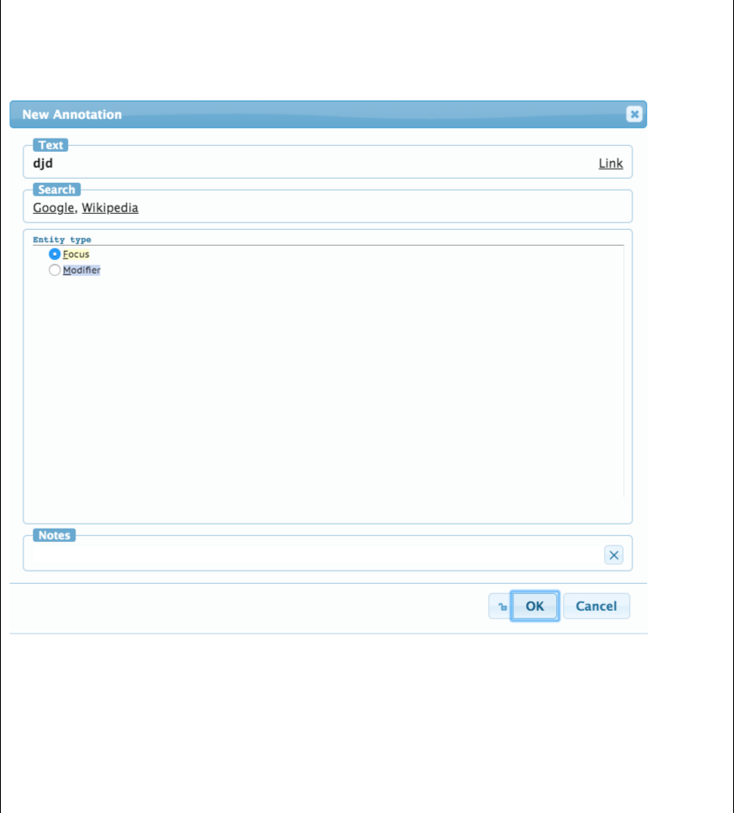

Focus: the main focal concept (there may only be ONE per problem list entry).

Modifier: any other text span that modifies the focal concept. This can be an adjective-type modifier (like ‘severe’ or ‘recent’), or another associated problem (like ‘CHF’).

Classifying Relationships

The next step is to classify the relationship type between the focal concept and the modifiers.

This is done by clicking on the “Focus” box above the focal concept, holding the click and dragging

Back to CONTENTS

Instructions for Annotation Guide Creation | Updated by LAC on 08/23/2019 | Rev 1
I Guidelines | 5

This is where all necessary information & directions regarding the annotation task go

to the ‘Modifier’ box of the modifying concept. Note that it is important to click and drag from the ‘Focus’ and ‘Modifier’ boxes above the text, not the text itself, as shown below:

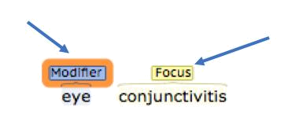

Once you have made the connection, a dialog box will allow you to select the appropriate relationship:

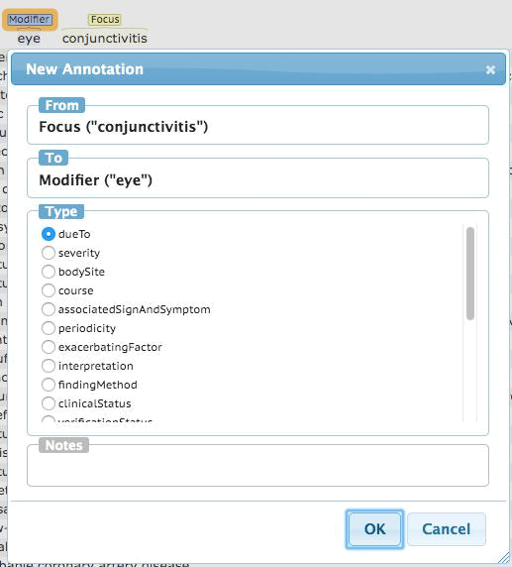

General Brat Rules of Thumb

Generally, relationships will start from the focus concept and go to the modifiers, meaning the arrow will generally point away from the focus as shown here:

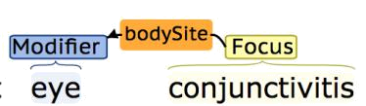

In general, the arrow points to the thing that modifies. Read the above as “conjunctivitis has body site eye.’

Modifiers will now always modify the focal concept, however. Sometimes modifiers will modify other modifiers. For example, ‘eye’ here is modified by a ‘left’ laterality:

Back to CONTENTS

Instructions for Annotation Guide Creation | Updated by LAC on 08/23/2019 | Rev 1
I Guidelines | 6

This is where all necessary information & directions regarding the annotation task go
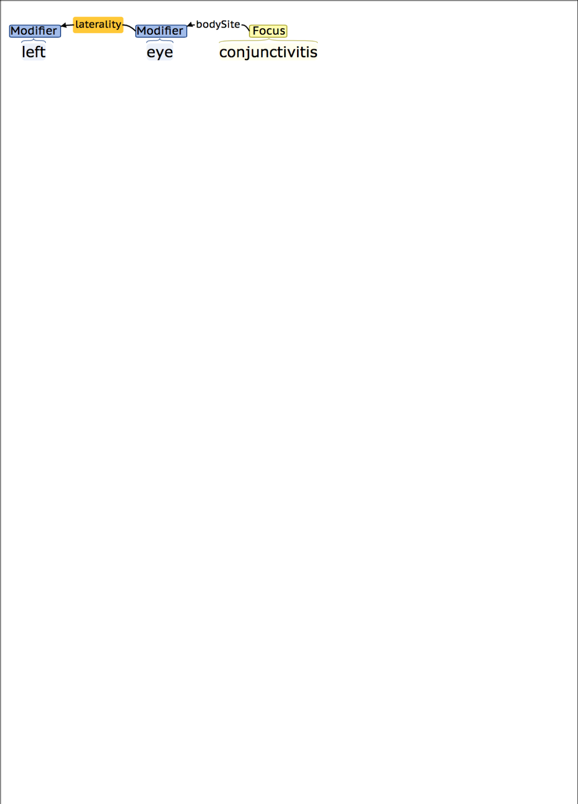

The same directionality rules apply here – ‘left’ modifies ‘eye,’ so the arrow starts from ‘eye’ and points to ‘left.’

Changing/Deleting Annotations

If you need to delete or modify an annotation, double click either on the ‘Focus’ or ‘Modifier’ box above the text span, or the label of the linking relationship. This will bring up a dialog box showing options to change or delete the annotation.

Note that that Brat will not allow you to delete a ‘Modifier’ or ‘Focus’ annotation that has a relationship attached. To delete a ‘Focus’ annotation, for example, you must first delete all relationships originating from it.

Keyboard Shortcuts

The following can be used to select annotation types via keyboard shortcuts

Text Span Types:

- Focus

mModifier

Relationship Types:

d dueTo

s severity

- bodySite

- course

a associatedSignAndSymptom

p periodicity

x exacerbatingFactor

I interpretation

- findingMethod

- clinicalStatus

- verificationStatus

o ruledOut

l laterality

e anatomicalDirection

y certainty

r risk

g stage

w occurredFollowing

- otherwiseRelated

nnegated

Back to CONTENTS

Instructions for Annotation Guide Creation | Updated by LAC on 08/23/2019 | Rev 1
I Guidelines | 7

This is where all necessary information & directions regarding the annotation task go

h historical

Another example

Please use this document for annotation to make sure we are consistently collecting the same information in the same way.

Annotators will be given access to a sample of clinical notes with .txt file format. After opening a .txt file in the MAE tool and allowing MAE to convert the file to an .xml format, annotators will be tasked with two primary goals. First, annotators will verify whether or not the patient meets the criteria for “chronic pain” (ref. 4.1 below). Second, annotators will identify and highlight keywords or phrases pertaining to the following concepts:

- Pain

- Date

- Cause

- Location

- Severity

- Effects

- Diagnostic Intervention

- Medication

- Other Treatments

Annotators will then create tags for the highlighted span of text by right clicking and selecting a concept from the drop-down menu (n.b. a given span of text can be tagged with more than one concept, e.g. “headache” could be tagged as Pain and Location). Once a tag is created, additional attributes can be selected from drop-down menus within the given tag menu (ref. 5.2 below). The annotation will end when all medical records of that patient for a 2-year period are reviewed.

Back to CONTENTS

Instructions for Annotation Guide Creation | Updated by LAC on 08/23/2019 | Rev 1
I Guidelines | 8

This is where all necessary information & directions regarding the annotation task go

- Definitions

Organizing this section’s information into a table is highly recommended. The table should include a running list of all pertinent concepts and/or linkage parameters to be used in the annotation task along with descriptive definitions, example keywords, and further sub-lists of attributes (if applicable).

Example

 | dueTo | Further conditions, problems, diagnoses, procedures or
 |  | events or the substance that caused/triggered this Condition.
 | severity | A subjective assessment of the severity of the condition as
 |  | evaluated by the clinician.
 |  | Key Terms: severe | moderate | mild, …
 | bodySite | A structured anatomical location for the problem or
 |  | diagnosis.
 | course | Both the course and onset of a disease. Many conditions with
 |  | an acute (sudden) onset also have an acute (short duration)
 |  | course.
 |  | Key Terms: acute | chronic | intermittent, …
 | associatedSignAndSymptom | Physical observations captured by a clinician or subjective
 |  | conditions experienced by a patient that are related to a
 |  | medical condition.
 | periodicity | The length of time from one occurrence to the next.
 |  | Key Terms: daily, weekly, monthly, …
 | exacerbatingFactor | An action or intervention which makes a symptom more
 |  | severe.
 |  | Key Terms: “X exacerbated | aggrevated by Y”, …
 | interpretation | A clinical judgment about the significance of an evaluation
 |  | result. Interpretation is used to clarify data from
 |  | measurements and other evaluations. For example, if a
 |  | measured analyte is greater than a predetermined threshold
 |  | the interpretation could be Positive, or if a measurement is
 |  | lower than a normal physiological range the interpretation
 |  | could be low or critical low. Some values include normal,
 |  | abnormal, panic high, panic low, ... Interpretation may also
 |  | be used to indicate whether or not the result is outside the
 |  | range for the patient.
 |  | Key Terms: normal | abnormal
 | findingMethod | The means by which a clinical finding is determined.
 | clinicalStatus | The physiological state of the condition with respect to
 |  | whether it is actually of concern.
 |  | Key Terms: active | relapse | remission | resolved, …
 | verificationStatus | The verification status to support the clinical status of the

Back to CONTENTS

Instructions for Annotation Guide Creation | Updated by LAC on 08/23/2019 | Rev 1
 |  |  |  |  |  |  |  |  | I Guidelines |  |  | 9
 |  |  | This is where all necessary information & directions regarding the annotation task go
 |  |  |  |  |  |  |  |  | condition.
 |  |  |  |  |  |  |  |  | Key Terms: confirmed | unconfirmed | refuted | ruled out,
 |  |  |  |  |  |  |  |  | …
 |  |  | ruledOut |  |  |  |  |  | Identifies what potential diagnoses have been ruled out for
 |  |  |  |  |  |  |  |  | this condition.
 |  |  |  |  |  |  |  |  | Key Terms: “X but ruled out Y”
 |  |  |  |  |  |  |  |  | NOTE: This is intended to indicate that a problem other than
 |  |  |  |  |  |  |  |  | the focus was specifically ruled out.
 |  |  |  |  |  |  |  |  | For example, “Low-back pain, rule-out herniated disk”
 |  |  |  |  |  |  |  |  | If the focus itself has been ruled out, for example: “rule-out
 |  |  |  |  |  |  |  |  | migraine,” use the clinicalStatus annotation.
 |  |  | laterality |  |  |  |  |  | The laterality of a bilaterally duplicated structure.
 |  |  |  |  |  |  |  |  | Key Terms: left, right, bilateral, …
 |  |  | anatomicalDirection |  |  |  |  |  | Orientation with respect to the body.
 |  |  |  |  |  |  |  |  | Key Terms: proximal, distal, lateral, medial
 |  |  | historicalIndicator |  |  |  |  |  | Indicates a past occurrence of an action or event. For
 |  |  |  |  |  |  |  |  | example, 'history of fever' indicates fever occurred in the
 |  |  |  |  |  |  |  |  | past.
 |  |  | negatedIndicator |  |  |  |  |  | Indicates that the given annotation indicates a negative
 |  |  |  |  |  |  |  |  | assertion.
 |  |  | certainty |  |  |  |  |  | The level of confidence in the identification of the diagnosis
 |  |  |  |  |  |  |  |  | Key Terms: probable, uncertain, possibly, …
 |  |  | risk |  |  |  |  |  | An indication for a possibility of developing a specified
 |  |  |  |  |  |  |  |  | condition.
 |  |  | stage |  |  |  |  |  | Clinical stage or grade of a condition. May include formal
 |  |  |  |  |  |  |  |  | severity assessments.
 |  |  |  |  |  |  |  |  | Key Terms: stage T1a | stage III | metastasis
 |  |  | occurredFollowing |  |  |  |  |  | Further conditions, problems, diagnoses, procedures or
 |  |  |  |  |  |  |  |  | events or the substance that preceded this Condition.
 |  |  | otherwiseRelated |  |  |  |  |  | Otherwise meaningfully clinically related (not covered by
 |  |  |  |  |  |  |  |  | any of the above).
 | Another example
 |  |  | Tag Name/Concepts |  |  |  |  | Ex. Keywords/Phrases |  |  |  | Attributes
 |  |  |  |  |  |  |  |  | “pain” |  | certainty | confirmed
 |  |  |  |  |  |  |  |  | “myalgia” |  |  | hypothetical
 |  |  |  | Pain |  |  |  |  | “discomfort” |  |  | possible
 |  |  | signs and symptoms of |  |  |  |  |  | “spasm” |  |  | negated
 |  |  | pain are present in the |  |  |  |  | “tenderness” |  |  | status | current
 |  |  | note |  |  |  |  |  | “soreness” |  |  | past
 |  |  |  |  |  |  |  |  | “ache” |  | experiencer | patient
 |  |  |  |  |  |  |  |  | “throb” |  |  | other

Back to CONTENTS

Instructions for Annotation Guide Creation | Updated by LAC on 08/23/2019 | Rev 1
 |  |  |  |  |  |  | I Guidelines |  | 10
 |  | This is where all necessary information & directions regarding the annotation task go
 |  |  |  |  |  |  |  | exclusion | yes
 |  |  |  |  |  |  |  |  | no
 |  |  |  | Date |  |  |  | date_type | initial_event_date
 |  | critical dates related to |  |  |  |  | “05-23-2009” |  | chronic_pain_identified |  | _date
 | genesis, identification, and |  |  |  |  |  | “January 12, 2010” |  | last_mention_date
 |  | resolving of pain
 |  |  |  |  |  |  |  | caused_by | injury_trauma
 |  |  |  | Cause |  |  | “fracture of the tibia” |  | surgical
 |  | etiology (if present) or |  |  |  |  | “fracture of the tibia” |  | musculoskeletal
 |  |  |  |  |  |  | “arthritis”
 | likely factors contributing |  |  |  |  |  | “arthritis” |  | neuropathic
 |  |  |  |  |  |  | “peripheral neuropathy”
 |  | to the pain |  |  |  |  | “peripheral neuropathy” |  | other_medical
 |  |  |  |  |  |  |  |  | other
 |  |  |  |  |  |  |  | Location | abdomen
 |  |  |  |  |  |  |  |  | ankle
 |  |  |  |  |  |  |  |  | arm
 |  |  |  |  |  |  |  |  | back
 |  |  |  |  |  |  |  |  | back-lower
 |  |  |  |  |  |  |  |  | back-upper
 |  |  |  |  |  |  |  |  | breast
 |  |  |  |  |  |  |  |  | buttocks
 |  |  |  |  |  |  |  |  | chest
 |  |  |  |  |  |  |  |  | ear
 |  |  |  |  |  |  |  |  | elbow
 |  |  |  |  |  |  |  |  | eye
 |  |  |  |  |  |  |  |  | face
 |  |  |  |  |  |  |  |  | foot
 |  |  | Location |  |  |  | “left knee” |  | generalized
 | location of the pain in the |  |  |  |  |  | “lower back” |  | groin
 |  |  |  | body |  |  | “proximal femur” |  | hand
 |  |  |  |  |  |  |  |  | head
 |  |  |  |  |  |  |  |  | hip
 |  |  |  |  |  |  |  |  | incisional
 |  |  |  |  |  |  |  |  | jaw
 |  |  |  |  |  |  |  |  | knee
 |  |  |  |  |  |  |  |  | leg
 |  |  |  |  |  |  |  |  | mouth
 |  |  |  |  |  |  |  |  | neck
 |  |  |  |  |  |  |  |  | nose
 |  |  |  |  |  |  |  |  | pelvis
 |  |  |  |  |  |  |  |  | shoulder
 |  |  |  |  |  |  |  |  | throat
 |  |  |  |  |  |  |  |  | wrist
 |  |  |  |  |  |  |  |  | other

Back to CONTENTS

Instructions for Annotation Guide Creation | Updated by LAC on 08/23/2019 | Rev 1
 |  |  |  |  |  |  |  |  |  |  | I Guidelines |  | 11
 |  | This is where all necessary information & directions regarding the annotation task go
 |  |  |  |  | Severity |  |  |  |  |  |  | attributes | Not Bothersome (0)
 |  |  |  |  |  |  |  |  |  |  | “tolerable” |  | Mild (1-3)
 | strength or intensity of the |  |  |  |  |  |  |  |  |  | “tolerable”
 |  |  |  |  |  |  |  |  |  |  | “9/10” |  | Moderate (4-6)
 |  |  | pain sensation |  |  |  |  |  |  |  | “9/10”
 |  |  |  |  |  |  |  |  |  |  |  |  | Severe (7-10)
 |  |  |  |  |  |  |  |  |  |  |  | manifest | movement
 |  |  |  |  |  |  |  |  |  |  | “missing a lot of school” |  | sleep
 |  |  |  |  |  | Effects |  |  |  |  | “missing a lot of school” |  | work_or_school
 |  |  |  |  |  | Effects |  |  |  |  | “annoyed that he is unable
 | effect of the pain on daily |  |  |  |  |  |  |  |  |  | “annoyed that he is unable |  | social_family
 |  |  |  |  |  |  |  |  |  |  | to bathe”
 |  |  | life/experience |  |  |  |  |  |  |  | to bathe” |  | other
 |  |  |  |  |  |  |  |  |  |  | “wakes him up at night”
 |  |  |  |  |  |  |  |  |  |  | “wakes him up at night” | emotional | bothered
 |  |  |  |  |  |  |  |  |  |  |  |  | not_bothered
 |  | Diagnostic_intervention |  |  |  |  |  |  |  |  |  | status | past
 |  |  |  |  |  |  |  |  |  |  |  |  | planned
 |  | procedure performed to |  |  |  |  |  |  |  |  | “chest x-ray”
 |  |  |  |  |  |  |  |  |  |  | “chest x-ray” |  | requested
 | diagnose the cause of the |  |  |  |  |  |  |  |  |  | “bloodwork”
 |  |  |  |  |  |  |  |  |  |  | “bloodwork” |  | recommended
 |  |  |  |  |  | pain
 |  |  |  |  |  |  |  |  |  |  |  |  | current
 |  |  |  |  |  |  |  |  |  |  |  | type | over_counter
 |  |  |  |  |  |  |  |  |  |  |  |  | prescription
 |  |  |  |  |  |  |  |  |  |  |  |  | herbal_natural_supplement
 |  |  |  |  |  |  |  |  |  |  |  |  | other
 |  |  |  |  |  |  |  |  |  |  |  | order | new
 |  |  |  |  |  |  |  |  |  |  |  |  | change_in_dose
 |  |  |  |  |  |  |  |  |  |  |  |  | continuation_of_regimen
 |  |  |  | Medication |  |  |  |  |  |  | “Oxycodone” |  | cancellation
 |  | name of medications |  |  |  |  |  |  |  |  | “Oxycodone” | status | past
 |  |  |  |  |  |  |  |  |  |  | “Tylenol” | status
 |  |  | *relevant to pain |  |  |  |  |  |  |  | “Tylenol” |  | planned
 |  |  |  |  |  |  |  |  |  |  | “aspirin”
 |  |  |  | treatment |  |  |  |  |  |  | “aspirin” |  | requested
 |  |  |  |  |  |  |  |  |  |  |  |  | recommended
 |  |  |  |  |  |  |  |  |  |  |  |  | current
 |  |  |  |  |  |  |  |  |  |  |  | effectiveness | alleviates
 |  |  |  |  |  |  |  |  |  |  |  |  | worsens
 |  |  |  |  |  |  |  |  |  |  |  |  | no_change
 |  |  |  |  |  |  |  |  |  |  |  | side_effects | present
 |  |  |  |  |  |  |  |  |  |  |  |  | none
 |  |  |  |  |  |  |  |  |  |  |  | type | education
 |  |  |  |  |  |  |  |  |  |  |  |  | surgery
 |  |  | Other_treatment |  |  |  |  |  |  |  | “cortisol injection” |  | hospitalization
 |  |  |  |  |  |  |  |  |  |  | “referred to neurology” |  | alternative_medicine
 |  | non-pharmaceutical |  |  |  |  |  |  |  |  | “referred to neurology”
 |  |  |  |  |  |  |  |  |  |  | “given educational |  | chiropractor
 | procedure/action to help |  |  |  |  |  |  |  |  |  | “given educational
 |  |  |  |  |  |  |  |  |  |  | materials about self-care” |  | injection
 |  |  | alleviate pain |  |  |  |  |  |  |  | materials about self-care”
 |  |  |  |  |  |  |  |  |  |  | “suggested CBT” |  | PT_OT
 |  |  |  |  |  |  |  |  |  |  |  |  | other
 |  |  |  |  |  |  |  |  |  |  |  | order | referral/consult

Back to CONTENTS

Instructions for Annotation Guide Creation | Updated by LAC on 08/23/2019 | Rev 1
I Guidelines | 12

This is where all necessary information & directions regarding the annotation task go

new

change_in_dose

continuation_of_regimen
cancellation

status past
planned
requested
recommended
current

effectiveness alleviates
worsens
no_change

side_effects present
none

Back to CONTENTS

Instructions for Annotation Guide Creation | Updated by LAC on 08/23/2019 | Rev 1
II Appendix | 13

This is where all supplemental/reference information goes; OK for this section to be messy

- Meeting Notes

After selecting the meeting date and providing attendee’s initials, fill in each note-category with as much or as little information as desired (simply enter “N/A” if there is nothing to add for that section). The Issues/Questions sub-section can include problems with the linguistic concepts, software tools, and processes as well as questions of a more general nature. Insights/Answers is the place where possible responses to the previous section’s problems can be listed along with any “pro-tips” or answers of a more general nature. And finally, every change made to the I Guidelines section of your annotation guide should be recorded in the Updates sub-section; these notes can be relatively high-level, e.g. “filled-in sections I-1, I-2, I-3, I-4, II-1, and II-3 with initial information; rev 1 created” would suffice when creating the first draft. Although it is not necessary to record changes made to the II Appendix or III Schedule sections, it certainly wouldn’t hurt (especially if a significant alteration is made such as changing a target date or adding a particularly informative example).

Example

Meeting 1 | 8/22/2019 | Attendees: LAC, SF, MMJ

  - Issues/Questions

o Did not annotate summary page

o Data definition vs. cohort definition

o Cohort extraction method vs. data collection method

  - Insights/Answers

o MAE can automatically put a suffix at the end or saved files. Change by clicking

“Preferences” then “set annotator suffix”

  - Updates

o Eliminated “pain_trend” concept from the Definitions table

Meeting 2 | 8/30/2019 | Attendees: SF, JSF, MMJ, LAC

- Issues/Questions

o Looking through too many notes; eliminate some? o MAE tool freezes sometimes

- Insights/Answers

o We can’t eliminate any note-types at this stage

o If you don’t open too many tabs, MAE usually functions pretty well

- Updates

o Added supplemental section on “date” annotation

Back to CONTENTS

Instructions for Annotation Guide Creation | Updated by LAC on 08/23/2019 | Rev 1
II Appendix | 14

This is where all supplemental/reference information goes; OK for this section to be messy

- Examples

This section is where you should provide examples of a difficult or “tricky” nature as well as examples worth including for their robust and revealing character. These examples need not be as thorough or stepwise as the one provided in the Instructions section (I-3), and there is no such thing as too many examples.

Example

Annotation Examples:

Focus concept spans are highlighted in green, modifier spans are highlighted in yellow, and relationships types are shown as the connecting dashed lines:

Chronic renal failure most likely due to diabetic nephropathy |------------ dueTo ----------------|

Recurrent severe depressive disorder with psychotic symptoms

 |  |  |  |  | |--- severity ---| |  |  |  |  |  |  |  | |
 |  | |---- clinicalStatus ----| |  |  |  |  |  |  |  |  |  |  | |
 |  |  |  |  |  |  |  |  |  |  | |------ related -----|
Left |  |  |  |  |  |  |  |  |  |  | after recent
 |  | lower-extremity |  |  |  |  | numbness |  |  |  |  |  |  |  | fracture
 |  |  | |- bodySite -| |  |  |  |  |  |  |  |  |  | |
 |  |  |  |  |  |  |  | |-- occurredFollowing --|
 |  |  |  |  |  | , now
 | Upper lobe |  |  |  | pneumonia |  |  |  | resolved
|-- bodySite --|
 |  | |---- clinicalStatus ----|
 |  |  | primarily on |  |  |  |  |  |  | ,
 | Psoriasis |  |  |  |  |  |  | face |  | , | reoccurring
|---- |  |  |  |  | bodySite ----|
|----------- |  |  |  |  | course ----------- |  |  |  |  |  |  |  | |

Specific Annotation Guidance

Focus selection

Choose the smallest possible span that conveys the problem, condition, or diagnosis, but do not chose a span that indicates something very generic or non-specific.

Example:

Back to CONTENTS

Instructions for Annotation Guide Creation | Updated by LAC on 08/23/2019 | Rev 1
II Appendix | 15

This is where all supplemental/reference information goes; OK for this section to be messy

History of untreated depressive disorder

The main focus of this entry is ‘depressive disorder.’ Do not include ‘untreated’ here as it is a modifier. Similarly, do not include ‘History of’ as part of the focus, as that is a contextual/temporal modifier. Conversely, do not chose simply ‘disorder’ as the focus. Even though it could be argued that the focal problem is a ‘disorder’ modified by ‘depressive,’ a focus of simply ‘disorder’ is too generic does not convey the clinical intent. Generally, the focus span should be as short as possible while still capturing the intent.

Note that some medical terminologies may combine, or ‘pre-coordinate’ modifiers onto a disorder such that they become a single, identified concept. For example, consider the problem list entry Severe chronic rhinitis. SNOMED CT includes separate concepts for Severe, Chronic, and Rhinitis, as well as a single concept for all three together: 69646003 | Severe chronic rhinitis. For this example, we would expect an annotator to annotate the focus as ‘rhinits’ irrespective of if SNOMED CT (or other known terminology) includes a pre-coordinated concept representing the text.

There are, however, instances where a modifier (such as body site) contributes significantly to the semantics of the clinical problem. In these cases, excluding the modifier from the focus would leave a very generic focus that would not by very informative – and more importantly, would not capture the clinical intent of the problem.

Example:

Ear disorder

Breast cancer

For the first example, although ‘ear’ modifies ‘disorder’ by stating the body location, the ‘ear’ modifier is included in the focus code span to avoid a very general ‘disorder’ focus. Similarly, for Breast Cancer, the body site plays a significant role in the clinical semantics of cancer, so it is included.

Some examples of focus concepts that are too general and annotators should consider including a modifier with the focus:

disorder, illness, cancer, symptoms, syndrome

Note that even though in the two above examples we include the body site as the focus, we also do want to capture the ‘bodySite’ relationship (see the “Overlapping Focus/Modifier” section below for more information).

Unique Scenarios

Modifiers not related to the focus

If a modifier modifies a problem or condition that is not the focal code, it is necessary to annotate that relationship as well. Here, ‘mild’ is a severity modifier that modifies a related condition, ‘psychotic symptoms,’ should also be included in the annotation.

Back to CONTENTS

Instructions for Annotation Guide Creation | Updated by LAC on 08/23/2019 | Rev 1
II Appendix | 16

This is where all supplemental/reference information goes; OK for this section to be messy

|-- severity --| <-

modifier to non-focus

Recurrent severe depressive disorder with mild psychotic symptoms

|----

|--- severity ---|

clinicalStatus ----|

|

|

|-- associatedSignAndSymptom --|

Relationships with no subject

Disregard relationships with no subject. For example, in the following there is no ‘occurredFollowing’ relationship even though there is a temporal mention of ‘status-post’:

status-post left total hip arthroplasty |- bodySite -|

Here is an example where ‘occurredFollowing’ would be appropriate. Note also here that the focal concept has changed to ‘Pain.’

Pain status-post left total hip arthroplasty

|

|----------

|- bodySite -|

occurredFollowing ----------|

Overlapping Focus/Modifier

Sometimes a modifier may be included in the focus code to avoid an overly generic or uninformative focus. If the focus span includes a modifier, still do annotate the relationship.

Example:

Intestinal disorder

|-- bodySite --|

Here, “Intestinal disorder” was chosen as the focus. The focus itself included the body site modifier, which was also noted. Note that these are special cases and if possible, it is preferred to exclude modifiers from the focal code. In this case ‘Intestinal’ is included in the focus because it avoids a generic ‘disorder’ focus.

Error States

Two focal concepts

If an entry has two problems that are in no way clinically related, skip the entry. This is done because if there are two unrelated problems stated in an entry it is impossible to assert a single focus. Only do this if you are certain there can be no clinically meaningful relationship between the two (even the most generic ‘related’ relationship).

Back to CONTENTS

Instructions for Annotation Guide Creation | Updated by LAC on 08/23/2019 | Rev 1

II Appendix | 17

This is where all supplemental/reference information goes; OK for this section to be messy

Example:

Tonsillitis and fracture of the femur.

No focal concept

If an entry has no focus that can be defined as a condition, problem or diagnosis, skip the entry.

Examples:

Return visit

Test results

Medication refill

- References/Links

Keep a running list of all relevant citations like you would for a manuscript. It’s also a good idea to include any helpful links for things such as external resources (webpages), tutorials, videos, etc.

Example

The selected relationships cover a subset of the attributes in the FHIR Condition Resource, as well as a set of common Condition Extensions:
Core FHIR attributes: (https://www.hl7.org/fhir/condition.html)
Extensions: (https://www.hl7.org/fhir/condition-extensions.html)

CEM (ClinicalAssert)

CIMI (FindingSiteAssertion) OpenEHR (Problem/Diagnosis)

Another example

Annotation criteria:

Yim et al, Annotation of pain and anesthesia events for surgery-related processes and outcomes extraction, Proceedings of the BioNLP 2017 workshop, pages 200-205, Vancouver, Canada, Aug 4, 2017

Dorflinger et al, Development and application of an electronic health record information extraction tool to assess quality of pain management in primary care. TBM, 2014. 4:184-189.

Annotation:

Leech G. Corpus Annotation Schemes. Literary and Linguistic Computing. 1993;8:275-81. 10.1093/llc/8.4.275.

Krippendorff, K. (2004). Measuring the reliability of qualitative text analysis data. Quality & quantity, 38, 787-800.

Back to CONTENTS

Instructions for Annotation Guide Creation | Updated by LAC on 08/23/2019 | Rev 1
III Schedule | 18

This is where all important dates go

In addition to the requirement that the Phase I Start Date be filled in immediately on the first day, it is recommended that the Phase I Target End Date be selected as well. It is understood that this table will be continuously updated throughout the annotation process, so simply select dates in the provided table and list additional important dates (e.g. a grant submission deadline) as they arise.

Example

Phase |  | Start Date |  | Target End Date |  |  | Actual End Date
I (Plan) | 6/5/2019 |  |  | 6/12/2019 |  |  | 6/11/2019
II (Train) | 6/11/2019 |  |  | 6/18/2019 |  |  | 6/21/2019
III (Develop)
III (Develop) | 6/26/2019 |  |  | 7/24/2019 |  |  |  | Select date
IV (Produce)
IV (Produce) |  | Select date |  |  | Select date |  |  | Select date
V (Wrap-up)
V (Wrap-up) |  | Select date |  |  | Select date |  |  | Select date

Additional Dates

- 9/1/2019 | JAMIA article submission deadline

- Select date | Provide a brief description here

- Etc.

Back to CONTENTS

Instructions for Annotation Guide Creation | Updated by LAC on 08/23/2019 | Rev 1

